MATH 1073 Calculus I
Assignment 4
1. Determine whether f’(x) exists.
$$\left(a\right) f\left(x\right)=\left\{\begin{aligned}x\sin{\frac{1}{x}} if x≠0 \\ 0 if x=0\end{aligned}\right.$$
$$\left(b\right) f\left(x\right)=\left\{\begin{aligned}x^{2}\sin{\frac{1}{x}} if x≠0 \\ 0 if x=0\end{aligned}\right.$$
Ans:
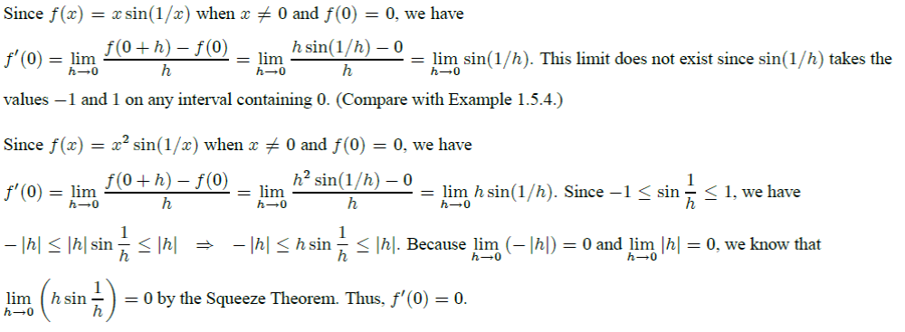

2. Find the derivative of the function using the definition of derivative. State the domain of the function and the domain of its derivative.
$$g\left(t\right)= \frac{1}{\sqrt{t}}$$
Ans:
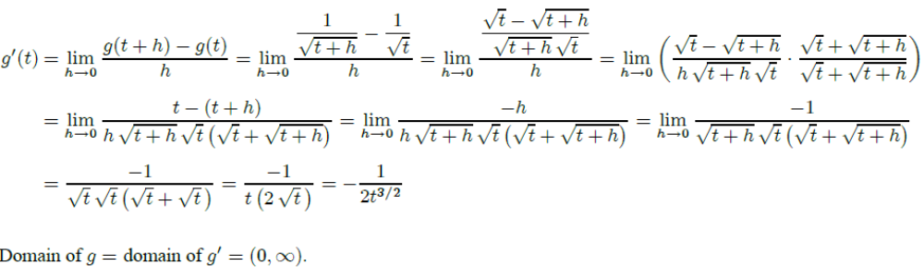

3-15 Differentiation the function.
3.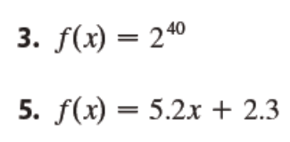
Ans:
4. f(x) = 5.2 x +2.3
Ans: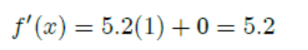
$$5. y=\frac{x^{2}+4x+3}{\sqrt{x}}$$
Ans:
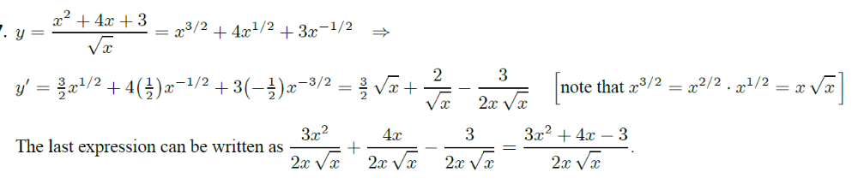
$$6. z= \frac{A}{y^{10}}+Be^{y}$$
$$z=Ay^{-10}+Be^{y}, so \frac{dz}{dy}=-10Ay^{-11}+Be^{y}$$

$$7. B\left(u\right)=(u^{3}+1)(2u^{2}-4u-1)$$
Ans:
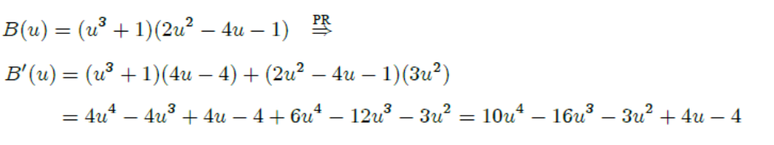
$$8. g\left(x\right)=\frac{1+2x}{3-4x}$$
Ans:
$$9. y=\frac{{(u+2)}^{2}}{1-u}$$
Ans:
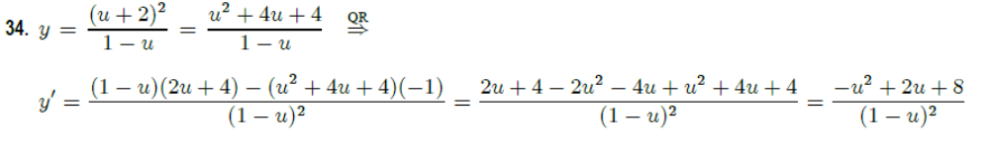
10. $f\left(x\right)=x^{2}\sin{x}$
Ans:
11. $g\left(t\right)=4\sec{t}+\tan{t}$
Ans:
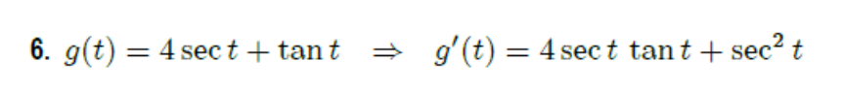
12. $y={(2x^{3}+5)}^{4}$
Ans:
13. $h\left(v\right)=v\sqrt[3]{1+v^{2}}$
Ans:
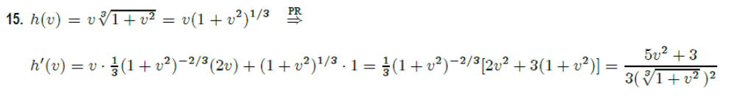
14. $y=e^{\tan{θ}}$
$$\frac{dy}{dθ}=e^{\tan{θ}}\sec^{2}θ$$

15. $f\left(t\right)=2^{t^{3}}$
$$f'\left(t\right)=\ln{2}∙2^{t^{3}}(3t^{2})$$

16. (a) Use the Quotient Rule to differentiate the function
$$f\left(x\right)=\frac{\tan{x}-1}{\sec{x}}$$
(b) Simplify the expression for f (x) by writing it in terms of sin x and cos x, and then find f’(x).
(c) Show that your answers to parts (a) and (b) are equivalent.

Ans:
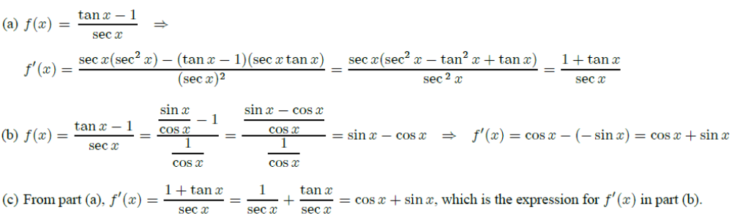

17. At what point on the curve $y=\sqrt{1+2x}$ is the tangent line perpendicular to the line 6x + 2y = 1?
Ans:
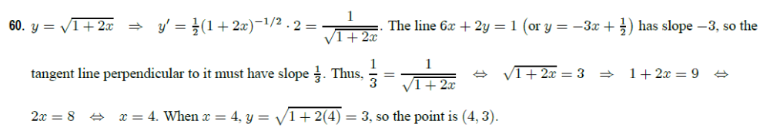

18. If F(x)= f (g(x)), where f (-2) = 8, f ’ (-2) = 4, f ’ (5)=3, g(5) = -2, and g ’ (5) = 6, find F’ (5).
Ans:

19.
A Cepheid variable star is a star whose brightness alternately increases and decreases. The most easily visible such star is Delta Cephei, for which the interval between times of maximum brightness is 5.4 days. The average brightness of this star is 4.0 and its brightness changes by 60.35. In view of these data, the brightness of Delta Cephei at time t, where t is measured in days, has been modeled by the function
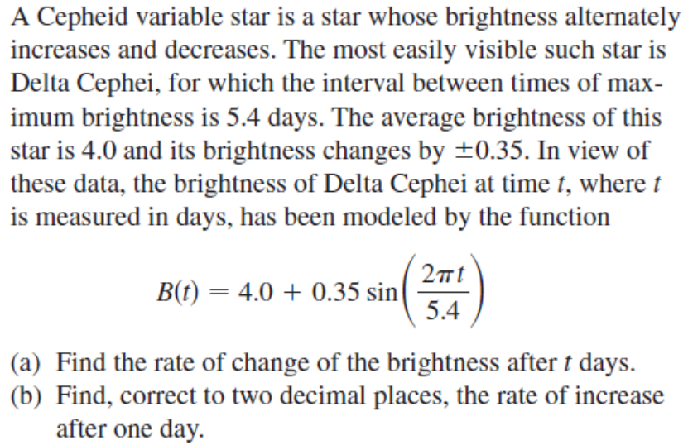
(a) Find the rate of change of the brightness after t days.
(b) Find, correct to two decimal places, the rate of increase after one day.

Ans:
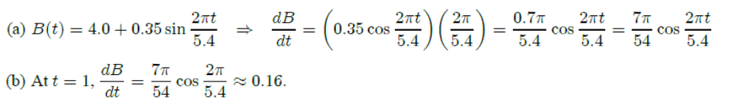

20. Find the limit.
(Hint: 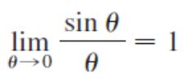, 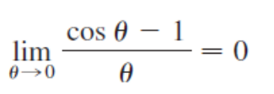 )
$$\left(a\right) \lim_{x→0}{\frac{\sin{x}}{\sin{πx}}}$$
$$\left(b\right) \lim_{θ→0}{\frac{\cos{θ}-1}{\sin{θ}}}$$
$$\left(c\right) \lim_{θ→0}{\frac{\sin{θ}}{θ+\tan{θ}}}$$
$$\left(d\right) \lim_{x→0}{\csc{x}\sin{(\sin{x})}}$$
Ans:
